Implementation:
To implement the Iceberg tables, we need to create External Volumes:
External Volumes hold the File data and table metadata, all in customer-supplied storage.
- Create External Volume:
- Before creating External Volume, Create Bucket and new Role on your AWS account
- Grant S3 full access policy to your new Role
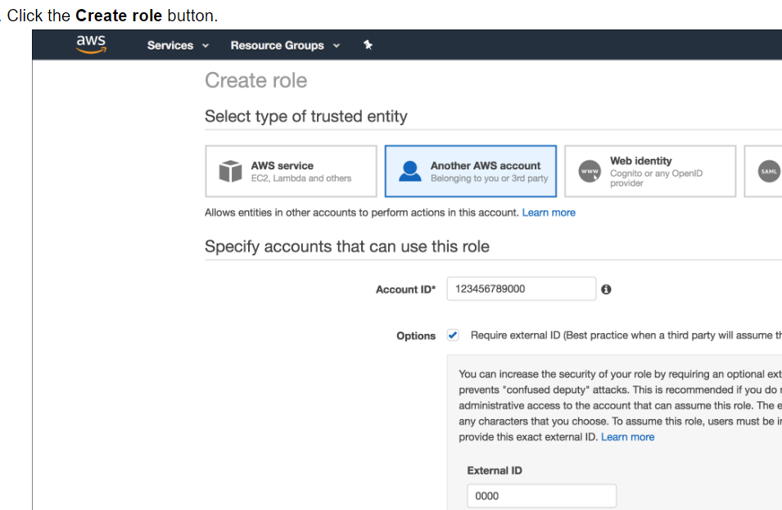

Create External Volume pointing to the S3 bucket
create external volume iceberg_int
storage_locations =
(
(
name = 'my-s3-us-east-2'
storage_provider = 'S3'
storage_base_url = 's3://icebergconfigbucket/'
storage_aws_role_arn = 'arn:aws:iam::913267004595:role/icebergconfigrole'
)
);

- DESC EXTERNAL VOLUME iceberg_int and copy the below highlighted parameters
{"NAME":"my-s3-us-east-2","STORAGE_PROVIDER":"S3",
"STORAGE_BASE_URL":"s3://icebergpracticebucket1/","STORAGE_ALLOWED_LOCATIONS":["s3://icebergpracticebucket1/*"],
"STORAGE_REGION":"us-east-2","STORAGE_AWS_ROLE_ARN":"arn:aws:iam::913267004595:role/icebergrole",
"STORAGE_AWS_IAM_USER_ARN":"arn:aws:iam::315033924470:user/i4v10000-s",
"STORAGE_AWS_EXTERNAL_ID":"QX73654_SFCRole=2_f2MhffRI7tL5Dlrr1HpqmsLmcwc="}

- Granting the IAM User Permissions to Access Bucket Objects
- Click the Edit trust relationship button of your new role.
- Modify the policy document with the DESC EXTERNAL VOLUME output values you recorded in previous step
- Click the Update Trust Policy button. The changes are saved

- Create Iceberg table: Two ways to create iceberg table:
Approach1:

create or replace iceberg table customer_detail (
CUST_NUM varchar,
CUST_STAT varchar ,
CUST_BAL number(10,0),
INV_NO varchar ,
INV_AMT number(10,2),
CRID varchar ,
SSN varchar,
phone number(10,0),
Email varchar
)
CATALOG = 'SNOWFLAKE'
external_volume='iceberg_int'
BASE_LOCATION = 'CUSTOMER_INFO';

create or replace storage integration s3_int
type = external_stage
storage_provider = s3
enabled = true
storage_aws_role_arn = 'arn:aws:iam::913267004595:role/testsnowflake'
storage_allowed_locations = ('s3://srcbucketsachin/');

desc integration s3_int

create or replace file format demo_db.public.csv_format
type = csv
skip_header = 1
null_if = ('NULL', 'null')
empty_field_as_null = true;

create or replace stage demo_db.public.ext_csv_stage
URL = 's3://srcbucketsachin/POC'
STORAGE_INTEGRATION = s3_int
file_format = demo_db.public.csv_format;

list @demo_db.public.ext_csv_stage

copy into prod_tbl
from @demo_db.public.ext_csv_stage/Customer_Invc.csv
on_error = CONTINUE;

Approach2:

create or replace iceberg table customer_detail
with EXTERNAL_VOLUME = 'iceberg_int'
as select CUST_NUM, CUST_STAT, CUST_BAL,INV_NO, INV_AMT, CRID,SSN,PHONE,EMAIL from CUSTOMER;

